

Murrayhill Woods COA
6107 SW Murray Blvd., #313
Beaverton, OR 97008
503-319-5848 Cell-Text-MMS/SMS
www.MurrayhillWoods.com

MURRAYHILL WOODS CONDOMINIUMS 2026 OWNER PACKET

TABLE OF CONTENTS

YEAR-END SUMMARY
Murrayhill Woods Condominiums Year-End Summary Points & Action Items.. 2-4

2026 DOCUMENTS:
2026 Notice of Dues………..……………….………………………………….. 5
2026 Annual Budget (approved).………………………………………………. 6
2026 Fee Allocation Schedule………………………………………………….. 7
Vehicle Registration Form (Return no later than January 31st)…..………….. 8
2021 Insurance Deductible Resolution………………………………………….. 9-10
2025 Reserve Study can be found at www.MurrayhillWoods.com 2020 Leasing Resolution can be found at www.MurrayhillWoods.com

IMPORTANT DOCUMENTS ENCLOSED!
PLEASE REVIEW CAREFULLY.

- NOTICE OF DUES INCREASE ENCLOSED.
- NOTICE OF INSURANCE DEDUCTIBLE INCREASE ENCLOSED.

Murrayhill Woods COA
6107 SW Murray Blvd., #313
Beaverton, OR 97008
503-319-5848 Cell-Text-MMS/SMS
www.MurrayhillWoods.com

YEAR-END SUMMARY

- Your Board of Directors adopted the 2026 budget at the board meeting held on November 17, 2025. It is the result of a proposed budget presented by Management along with the review and input of each of the Board members.
- The 2026 overall increase is 5.62%. The stability that Murrayhill Woods continues to realize has resulted in a minimal increase in HOA dues from 2025 to 2026. The reserve contributions for 2026 increases 2.5%. The Operating Budget increased overall 7.30% due largely to utility costs increase planned for 2026. Insurance premium increases are anticipated as well. The increase in the Reserves follows the schedule outlined and is necessary to complete projected repairs identified in the Reserve Study and 30-year Maintenance Plan without the need for any special assessments. Reserve contributions will compromise 33.85% of the total monthly HOA payment and the Operating contributions will comprise 66.15% of the total monthly HOA payment. Monthly HOA Dues will increase as follows beginning January 1, 2026:

If your HOA Dues were $297.00 in 2025, they will increase to $314.00 If your HOA Dues were $349.00 in 2025, they will increase to $369.00 If your HOA Dues were $350.00 in 2025, they will increase to $370.00 If your HOA Dues were $382.00 in 2025, they will increase to $404.00
- The combined operating and capital reserves for the 2026 budget increased to $757,234.00 with the operating budget being $500,900.00 and contributions to the reserves at $256,334.00 for the calendar year 2026.
- Based on 2025 expenses, the Board approved the Budget expense categories as follows:
Ground & Maintenance Repair………………………………………………. | - | 4.26%
Building Repairs & Maintenance……………………………………………. | + | 26.70%
Utility Expenses……………………………………………………………… | + | 4.95%
General Operating Expenses ………………………………………………… | + | 5.34%
Overall Increase from 2025 to 2026…………………………………………. | + | 5.62%
The above percentages are based on the needs from actual spending in 2025 and projected trends that are expected in 2026.

  - Grounds and Maintenance comprises approximately 5.94% of the annual operating budget.
  - Building Repairs and Maintenance comprises approximately 11.34% of the annual operating budget.
  - Utility costs continue to increase and it can be expected that this category will increase again in 2027.

Other increases are due to ongoing increases from the utility companies and the cost of onsite garbage maintenance. With more residents staying home since the pandemic, there has been a significant increase in the amount of garbage. PLEASE remember that if a dumpster is full (meaning the lid is raised), you (or your Tenants) are required to take your garbage to an alternate dumpster for disposal. Failure to do so may result in a fine being assessed to your unit. Utilities are 29.41% of the annual budget (the largest percentage of all categories)
  - Operating expenses account for 19.45% of the budget.
- The Board and Management are managing collections & delinquencies very effectively. Delinquencies are down from $595.50 on 12/31/2024 to $261.75 as of 10/31/2025. The delinquency is due to one unit being less than 30 days over due. Other than that account, there are no other delinquencies currently.
  - The Reserve Study and 30-year Maintenance plan draft has been updated and uploaded to the Association website www.MurrayhillWoods.com. Projections indicate that the proposed funding model will adequately accommodate the needs of the Association. The outlined funding schedule requires 2.5% annual increases through 2026, then increases 2.50% each year from 2026 through 2031, and then decreases to 0% through 2039. This schedule is projected to adequately fund the needed repairs and replacements without need for any special assessment.
  - All Owners continue to pay their COA dues online through the portal at www.PayFreshStart.com. Please note that HOA dues are due on the first of each month, and considered late if payment is not received on or before the 10th of each month. Additionally, maintenance requests can also be submitted from this portal. Management is happy to help you set up or process payments.
  - The Association website at www.MurrayhillWoods.com continues to grow with an abundance of information about the Association. You can download most documents directly from the website for free. Unlike most Associations who charge for documents through services like CondoCerts or Homewise, Murrayhill Woods provides access to documents at no charge to Owners, or prospective Buyers.
  - The Board is happy to announce that there are no pending special assessments, pending litigation, or any other areas of concern as of the end of 2024.

ACTION →✓ Insurance Deductible increased from $10,000 to $25,000 on January 1, 2022. Each Unit Owner must contact their insurance carrier to determine how this change will affect their policy. The new deductible will be $25,000 “per unit” for all water damage claims, and $25,000 “per occurrence” for all other claims. Each Unit Owner & Tenant shall be responsible for obtaining at his or her own expense, insurance covering his or her property (per Murrayhill Woods Condominiums Bylaws (Article 8, Section 8.7). Failure to do so is a violation and is subject to a fine. If you haven’t done so, please make certain to add the following additional interest on your Owner’s and Renter’s policies:
Murrayhill Woods Condominiums – C/O 6107 SW Murray Blvd., #313; Beaverton, OR 97008
Additional information about the insurance deductible increase is included in this packet.

ACTION →✓ Are you in Compliance?: If you are leasing your Unit, you are required to provide within 15 days of entering a Lease/Rental Agreement all documentation and fees as defined in the Murrayhill Woods Leasing Resolution dated 7/17/2019 (the Leasing Resolution can be found at www.MurrayhillWoods.com). Failure to provide the defined information within the time specified is a violation and is subject to a fine. If you have not done so already, all lease documentation or lease updates should be emailed to Manager@FRESHSTARTofOregon.com

ACTION →✓ Vehicle Registration Updates: All vehicles must be registered with the Association (MHW Rules & Regulations). Failure to update vehicle registrations or license plate changes (either as an owner or a landlord on behalf of his tenant) is a violation. A vehicle registration form is included in this packet. Please complete the vehicle registration form either online through the link on the form or fill out the form and and return it to management no later than January 31, 2026 to remain in compliance. Email your updated vehicle registration form to Manager@FRESHSTARTofOregon.com or mail your vehicle registration form to the address shown at the top of this notice no later than January 31, 2026 to avoid a violation and fine.

- No Smoking Community: This is a friendly reminder that Murrayhill Woods Condominiums is a No Smoking community. Smoking is strictly prohibited anywhere within the boundaries of Murrayhill Woods including inside any unit, in the parking lot, in a vehicle in the parking lot, on the sidewalks, or in any common or limited common area. Smoking is defined as inhaling, exhaling, burning, or carrying any lighted or smoldering cigarette, cigar, tobacco product, marijuana product, and all similar substances (i.e. e-cigarettes or vaping products), whether legal or illegal. All smoking, if any, shall take place completely off site. Cigarettes and cigarette butts shall not be disposed of anywhere on the ground or in common areas or dumpsters. Anyone found violating this provision shall be subject to a fine of $250.00 per occurrence. No warnings are provided. Owners are responsible for Tenants and their guests.

- Vandalism Concerns: Since the pandemic began, the crime rate for stolen mail and vehicle break-ins has risen considerably. It is highly advised that no valuables or sensitive information are left in your vehicles overnight. Also, please remove your mail often from your mailboxes. If you experience a break-in or observe suspicious activity within the community, please contact Beaverton non-emergency at 503-629-0111 right away. Your report of information may help to solve other similar crimes in the area. Murrayhill Woods has experienced some vehicle break-ins this year, including the removal of two catalytic converters from vehicles. Owners are encouraged to install cages around their catalytic converters to prevent vandalism. If you see anything that looks wrong, please let Management know right away. Try to take photos with your phone.

- Pet Policy: Murrayhill Woods has a strict no-dog policy (Bylaws Section 7.4). Only one indoor cat is allowed per unit with prior board approval except as otherwise required by law (ADA, Fair Housing Act, Section 504, or other applicable state/ federal law). All animals require prior approval prior to being brought onsite. Failure to obtain prior approval will result in a fine.

- Patio & Balcony Violations: There still are a lot of residents who are placing prohibited items on their patios and are receiving violation notices and fines. This may be due to the transient nature of Tenants, and Owners failing to inform their Tenants about the Rules and Regulations within the community. Please visit www.MurrayhillWoods.com and refer to the Rules and Regulations to become familiar with what items are allowed to be placed on patios and decks. If a patio item is not listed as a permitted item within the Rules & Regulations, it is not allowed on the patio and a fine may be imposed. The Rules & Regulations are a good resource for knowing what rules are enforced throughout the community. Please remember that no warnings are provided when a violation occurs, and all Residents are expected to know and follow the rules that are in place.
Information provided by:

FRESH START Real Estate, Inc. Community Manager Manager@FRESHSTARTofOregon.com 503-319-5848 Cell-Text-MMS/SMS

Murrayhill Woods COA
6107 SW Murray Blvd., #313
Beaverton, OR 97008
503-319-5848 Cell-Text-MMS/SMS
www.MurrayhillWoods.com

2026 DUES NOTICE

This serves as your notice that the total monthly HOA dues will increase beginning January 1, 2026. Refer to the following Budget and 2026 Fee Allocation Schedule.

  - If your dues are currently being paid via autopay, the amount will automatically update on 1/1/2026 and no action is required by you. However, if you are not on autopay, you MUST change the amount paid to avoid late fees. Please do not contact management for failure to update your dues payment, which may result in a late fee.

Effective January 1, 2026 HOA dues are as follows:
If your HOA Dues were $297.00 in 2025, they will increase to $314.00 If your HOA Dues were $350.00 in 2025, they will increase to $370.00. If your HOA Dues were $349.00 in 2025, they will increase to $369.00 If your HOA Dues were $382.00 in 2025, they will increase to $404.00

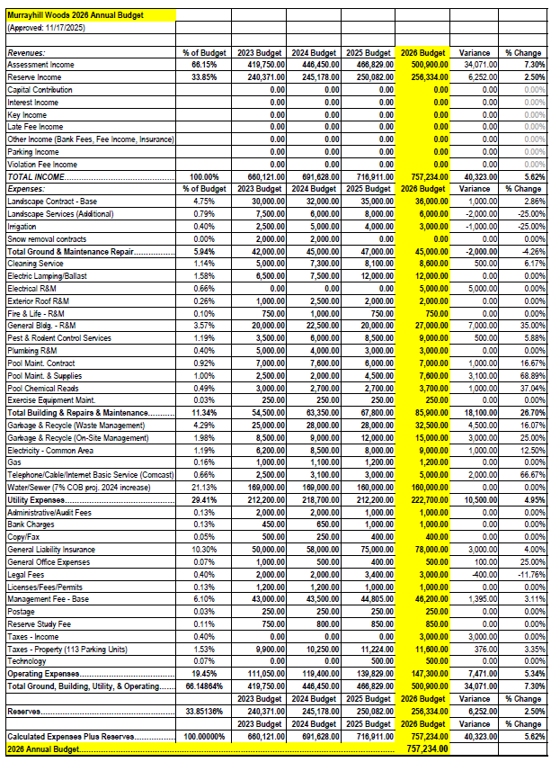

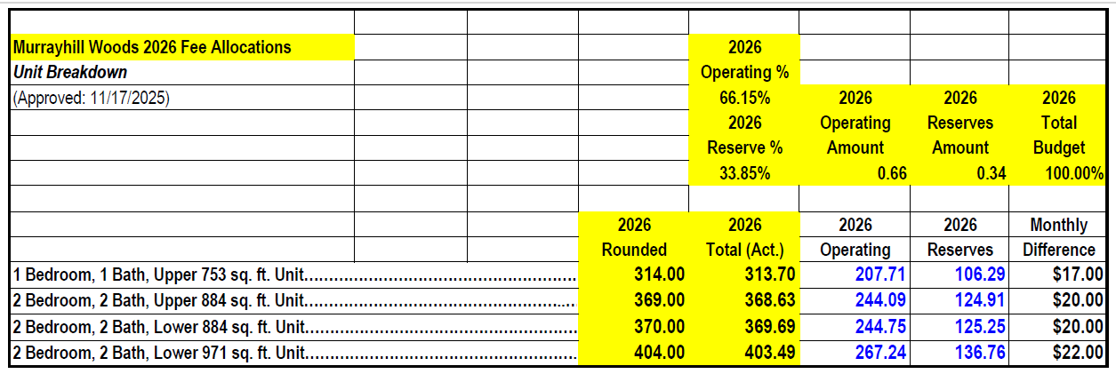

Murrayhill Woods Condominiums

Vehicle Registration Form

Click here to submit this form online: MHW Vehicle Registration Form | Murrayhill Woods

OWNER NAME

UNIT ADDRESS

MAILING ADDRESS

PRIMARY PHONE EMAIL

IF UNIT IS RENTED, THE FOLLOWING INFORMATION MUST BE COMPLETED

TENANT NAME(S)

PRIMARY PHONE SECOND PHONE

LEASE TERM EMAIL

VEHICLE INFORMATION
Registration is required for ALL vehicles per Murrayhill Woods Condominiums Declaration Section 6.2. Failure to register a vehicle is subject to a violation and fine as defined in the Murrayhill Woods Enforcement & Fine Resolution.

YEAR, MAKE & MODEL STATE & LICENSE PLATE NUMBER COLOR OF VEHICLE

YEAR, MAKE & MODEL STATE & LICENSE PLATE NUMBER COLOR OF VEHICLE

YEAR, MAKE & MODEL STATE & LICENSE PLATE NUMBER COLOR OF VEHICLE

AGREED: The Residents of this property have been advised that they are living in a Condominium Association and have been provided with copies of the Declarations, Bylaws, and adopted Rules & Regulations, which include Parking Rules established in the Governing Documents and by the Board of Directors and can be found at www.MurrayhillWoods.com. Signature on this form verifies that Owners and Tenants agree to abide by the above documents and rules set forth therein.

Owner Signature Tenant Signature (if applicable)

Owner Signature Tenant Signature (if applicable)

Date Date

Please mail or email completed form on or before January 31st of each year to:

FRESH START Real Estate, Inc.
6107 SW Murray Blvd., #313; Beaverton, OR 97008
(503) 319-5848 Cell-Text-MMS/SMS
Manager@FRESHSTARTofOregon.com

